My model
RLN16-410
RLC-410
Link for upgrade
https://reolink.com/firmware/#410
https://s3.amazonaws.com/reolink-storage/website/firmware/889_1708/RLC-410_889_17083001.zip
Current Version (before upgrade)
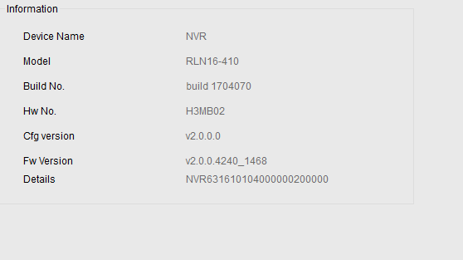

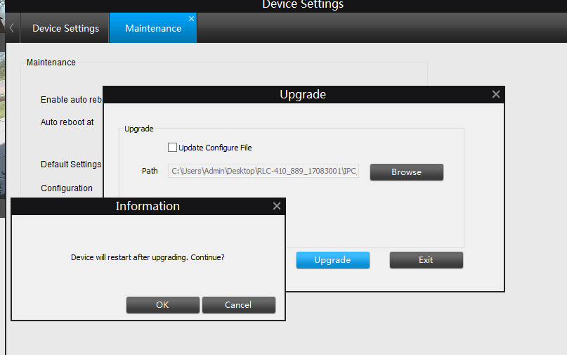

FAIL
